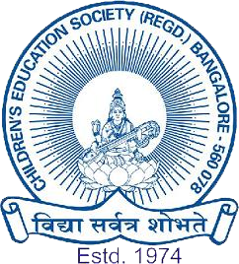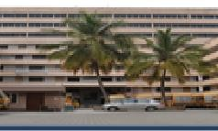
THE OXFORD GROUP OF INSTITUTIONS

THE OXFORD IND PU COLLEGE
JP NAGAR IST PHASE, BANGALORE-78

LIFE IS AN OPEN BOOK AND AN EDUCATION HELPS YOU WRITE SUCCESS STORIES

-JOYCE A MYERS

ADMISSIONS OPEN FOR I PUC ACADEMIC YEAR 2021-2022
COMPREHENSIVE TRAINING FOR BOARD + K-CET
COURSES OFFERED :

SCIENCE PCMB, PCMCS, PCME

COMMERCE SEBA, BEACS,

DIRECT ADMISSION FOR OXFORD SCHOOL STUDENTS

ARTS
HEPS

FACILITIES AND UNIQUE FEATURES
- Highly qualified, experienced, committed and motivated teaching faculties.
- The library enriched with latest text books, reference books, journals and internet facility.
- Well equipped laboratories with modern instruments.
- Revival Heritage Club and eco-club for Arts stream.
- Periodic Tests & Parents Meets regularly.
- Remedial classes for needy students.
- Encouragement for communication skills.
- Personal counseling to enhance students overall performance
and communication skills.
- Intensive CET coaching by experts for I, II PUC students. CA
Guidelines, commerce e-club for Commerce stream.

WE
GUARANTEED
FOR
EXCELLENT
RESULT

SHRI. SNVL .NARASIMHA RAJU SHRI.S.G.VISHWANATHA REDDY
CHAIRMAN PRINCIPAL

FOR MORE DETAILS CONTACT COLLEGE OFFICE:
Phone No:9845248428/7892479693/080-61754507/080-26659532
E-mail.ID: oxfordpuc@gmail.com WEBSITE:www.theoxford.edu

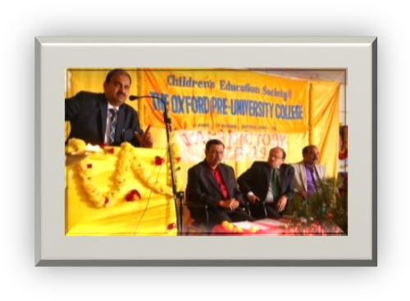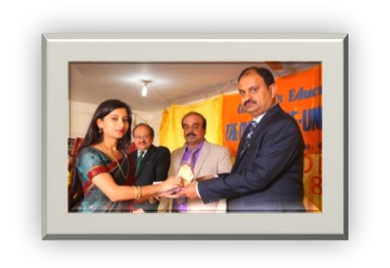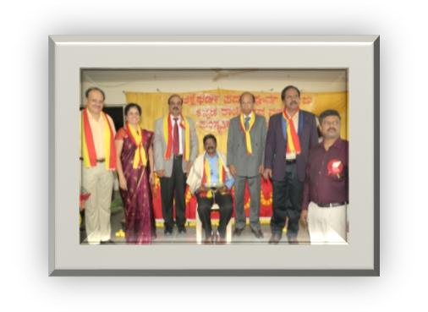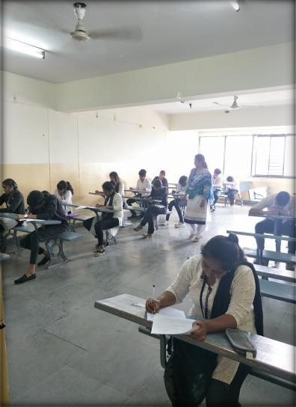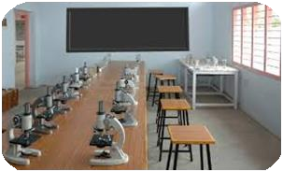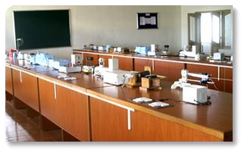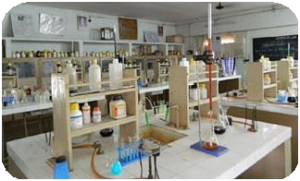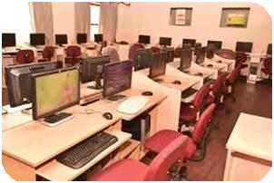
SPACIOUS CLASS ROOMS & LABORATORIES

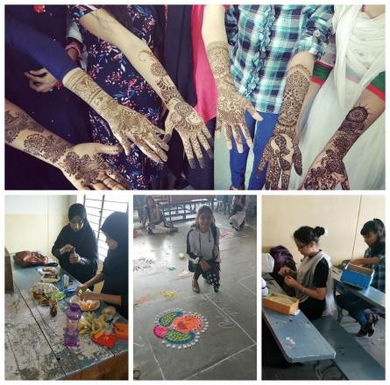VARIOUS EVENTS CONDUCTED IN THE COLLEGE
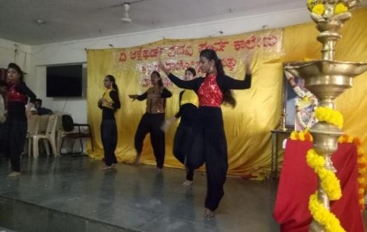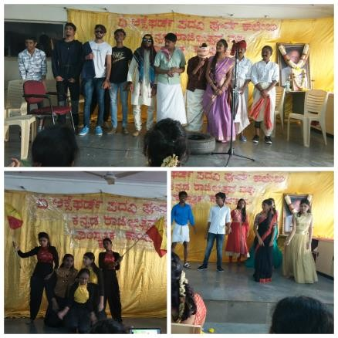

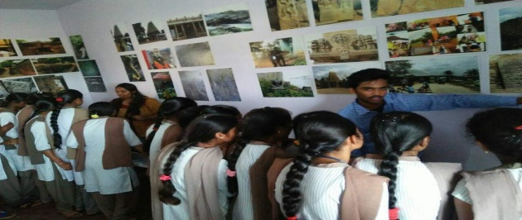

SPORTS EVENTS AND EXHIBITIONS

FOR MORE DETAILS CONTACT COLLEGE OFFICE:
Phone No: 9845248428/7892479693/080-61754507/080-26659532
E-mail. ID: oxfordpuc@gmail.com WEBSITE:www.theoxford.edu

